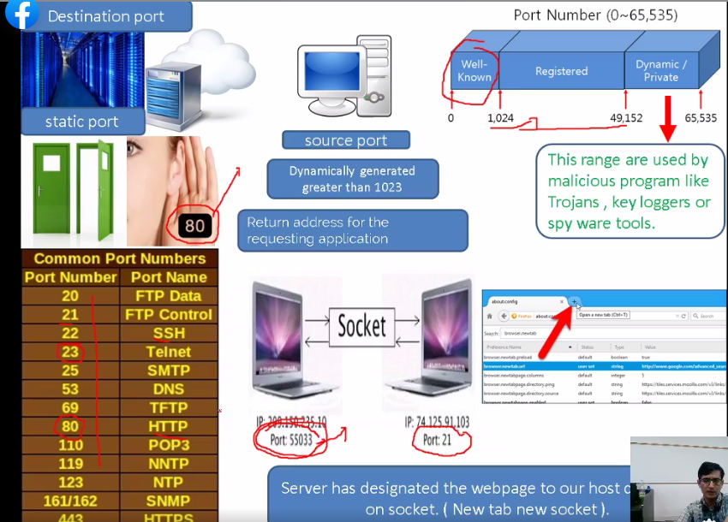

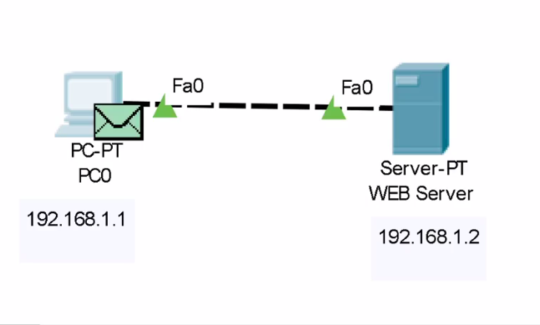

Pc se btowser ki req krne h toh side m simulation khula hona chahye packets show hogwy

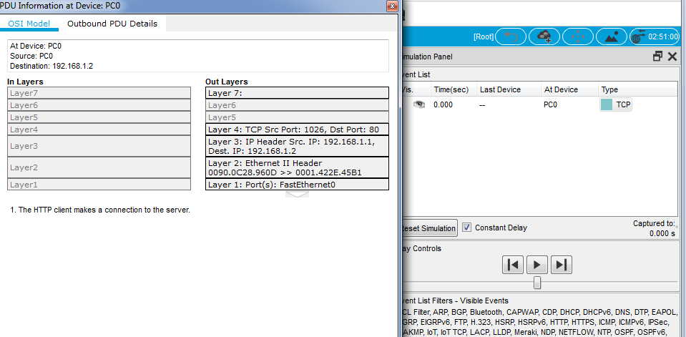

L3 packet

L4 segment

L2 frame

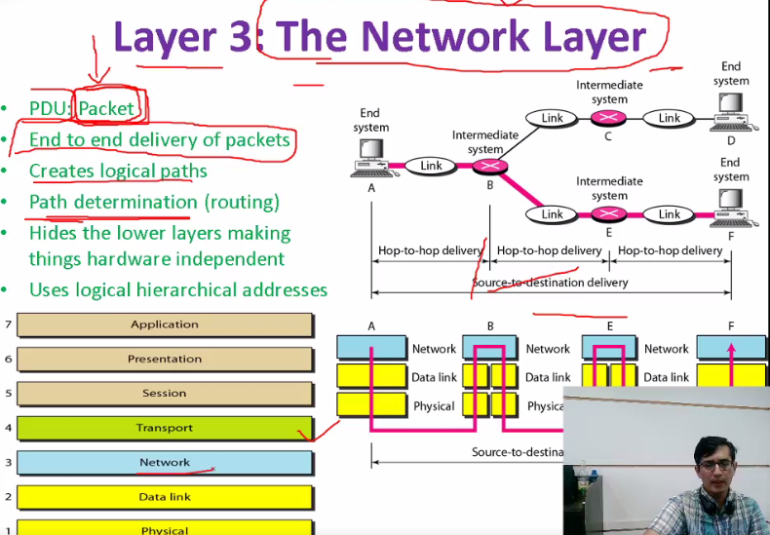

Responsible for end to end communication

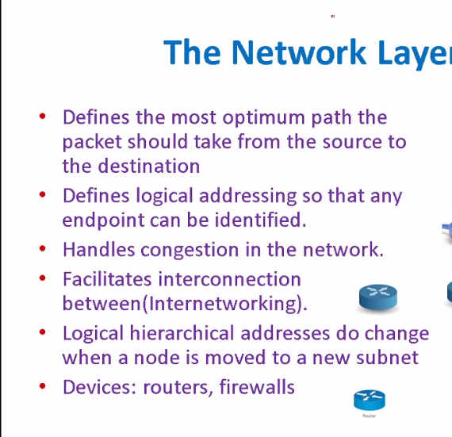

It gives us most optimum path

Logical address can be change here

Devices :routers firewalls

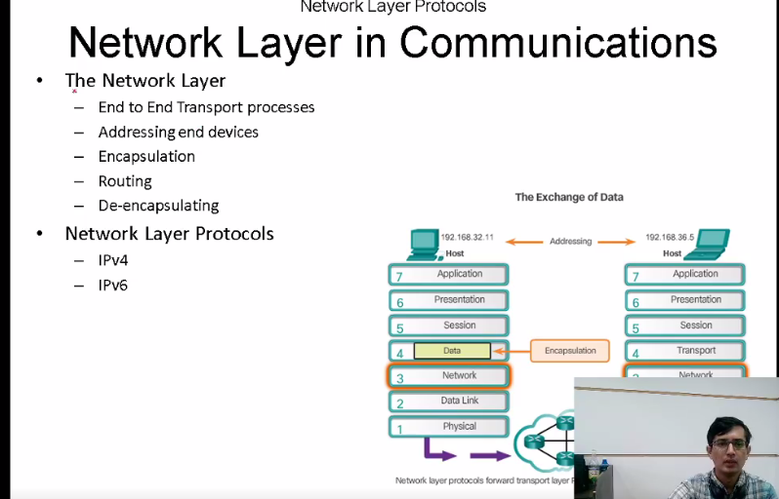

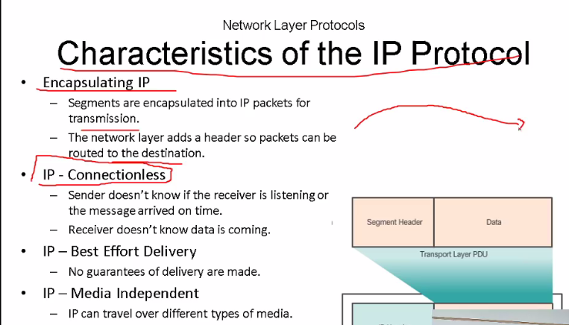

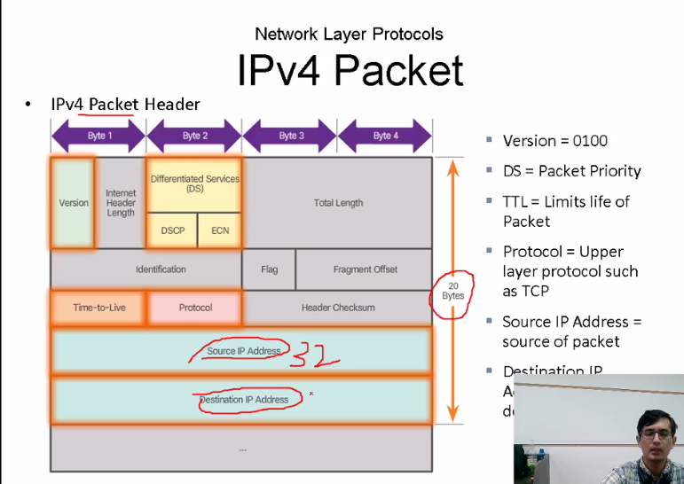

4 btye ka hota h humra ip aaddress

Proctols btaya tha h k upper layer m konse proctols m krna h tcp or udp .

Total length 20 bytee

TTL-------🡪 har hop count (max hop count)

Header checkums :integrity check krne k lye

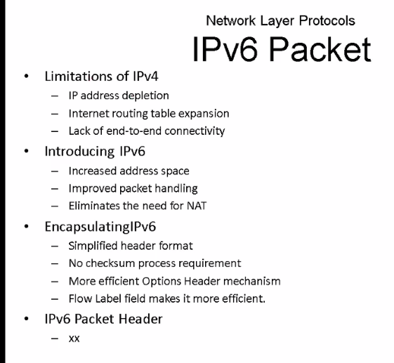

Total 40 bytes

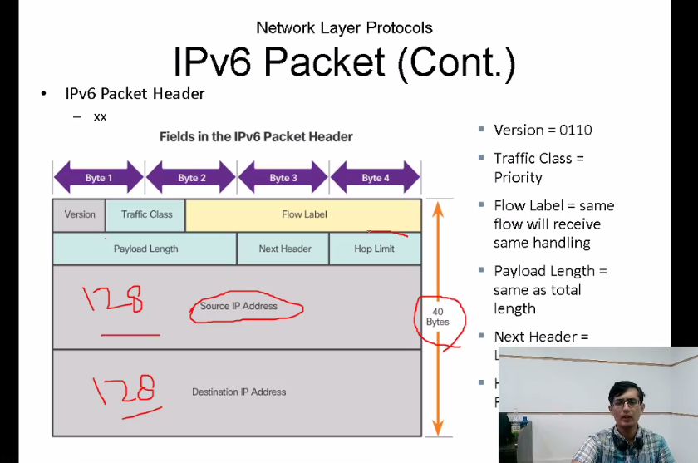

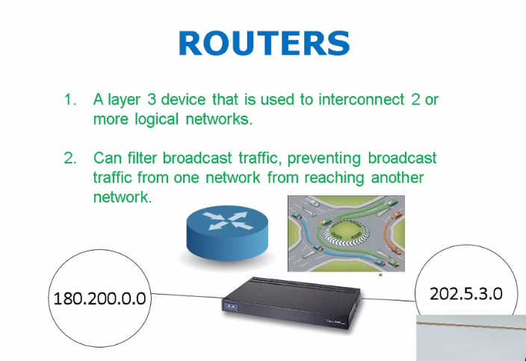

2 or more logical n/w ko connect krna its is on l3

Per port porbadcast hoti h

Ip address use for node to node coomunication

Humre n/w m public private addr sab a;aag hotey humre apne addr m private ip address chlrha hota h

Jab isp se connction letey h toh we got a router wagera toh use hum eek public ip address milta h toh wo router hume dhcp dervices k thorugh private ip address deta h wahan pe ek tech noti h jo NAT hoti h it translate private to public or public to private

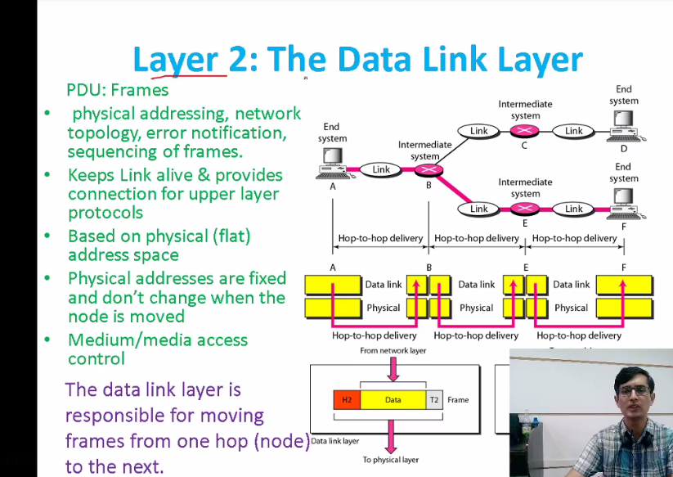

Work on mac address physical address

PDU Frames

Switch ki connectibity l2 dkhrhe hoti h

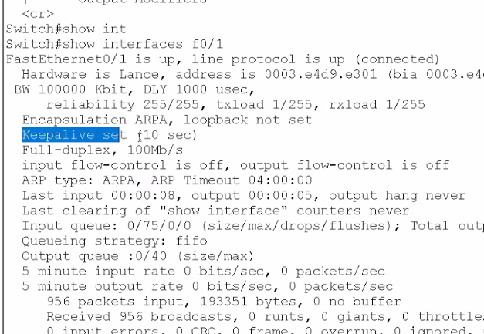

Keep alive har 10sec k bd check krta h k live h ya nh

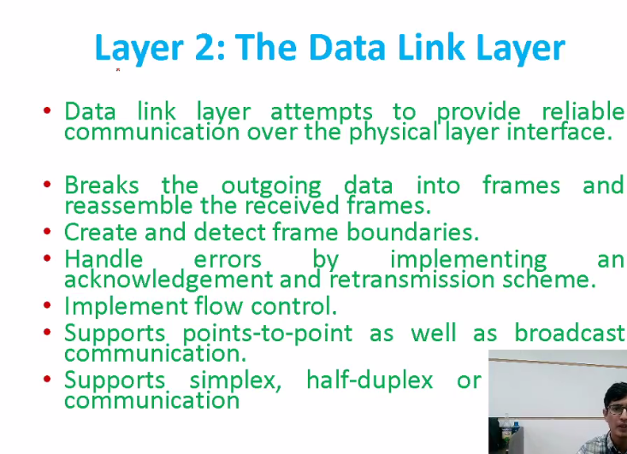

Header k sth trailor bhi hota h end m

Trailor m hash value hoti h pori frame ko calc kr k hash value add hogi

Phir receiving end pe bhi checkum value check hogi agar reveing pe bhi wohi milrhe hogit toh hi wo accept krega wrna reject hojayegaa

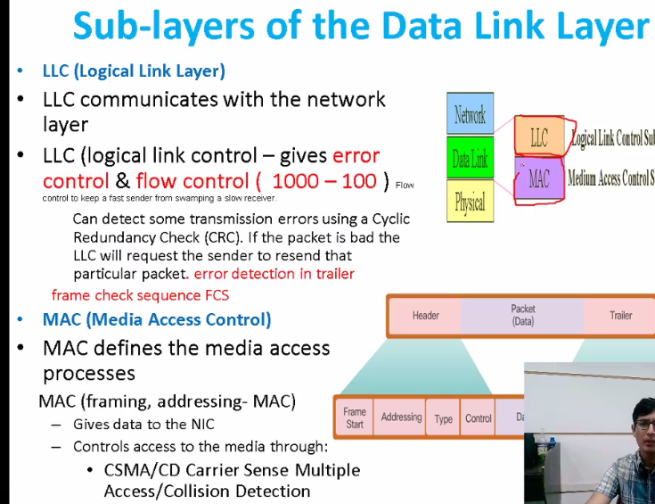

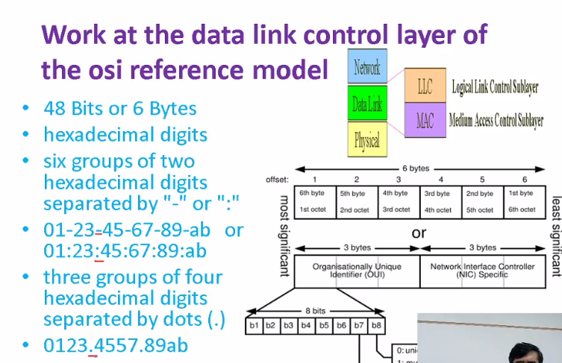

48 bit or 6 bytes

Snoofing m mac address change hota h is m mac address table ko unstable krdia jataa h

Toh us k lye we bind mac address statically using command

We can easily change our ip address

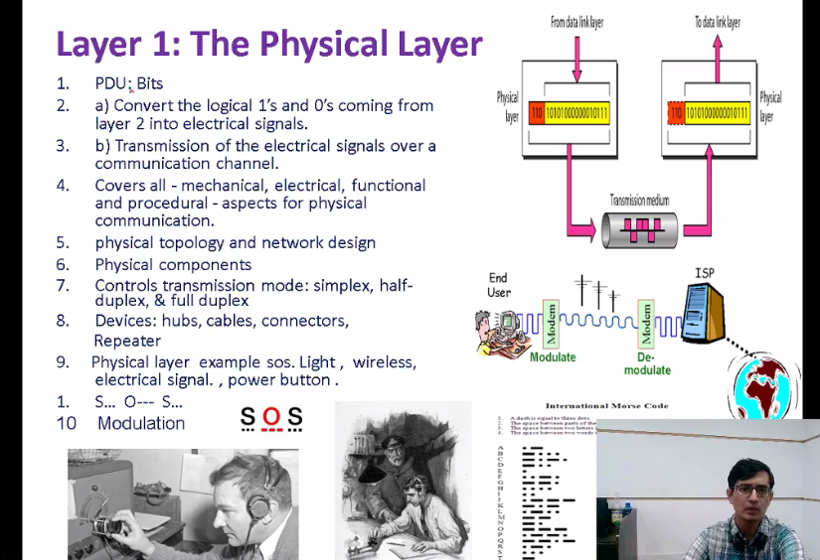

PDU:Bits

Devices saree physicals devices hub,cable,connector,repreater

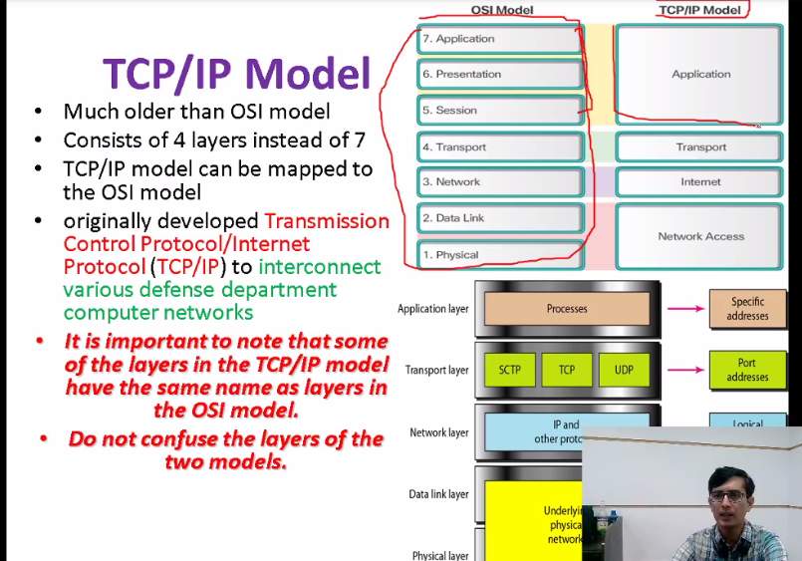

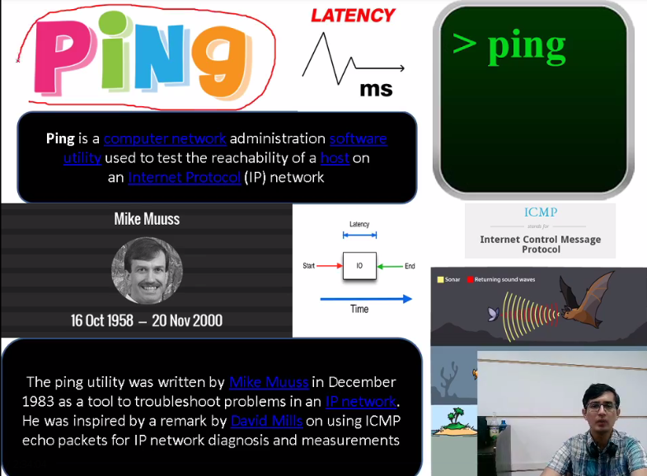

By default its 2 bytes

We can also change length of packet

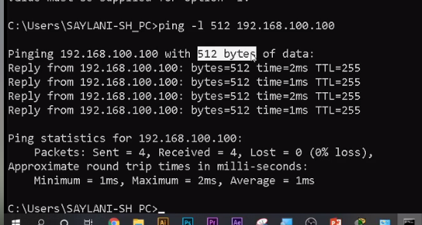

-t for time baki app sab help se dkhle

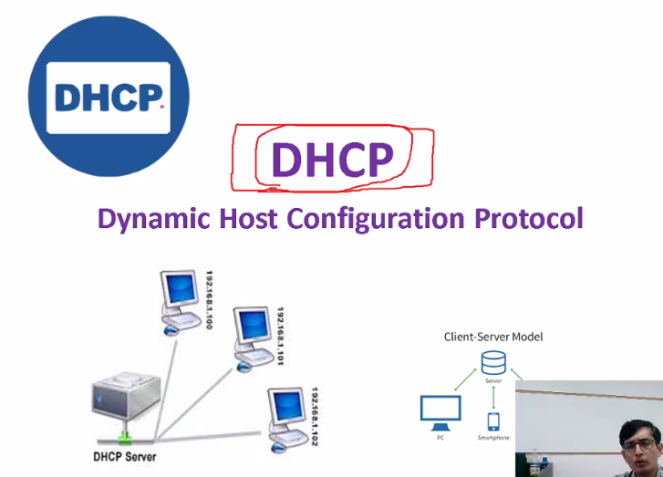

Why dhcp?

3 4 10 tk ki deivces ko ap manually kr sktey h par 1000 of user ho toh statically ip

Toh its diffuclt to islye humne dhcp server banaay ta k host ko automatically ips assign krta h

Hum isko ips ka pool detey h like 1 se le kr 100 tk ki IPs h ap k pass kuch bhi assign krdo

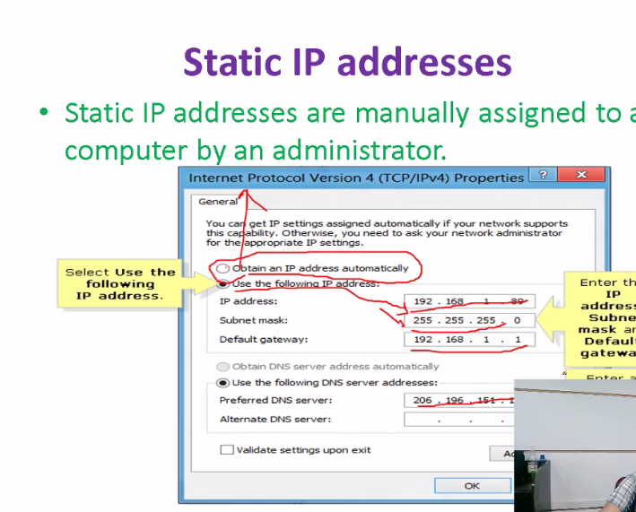

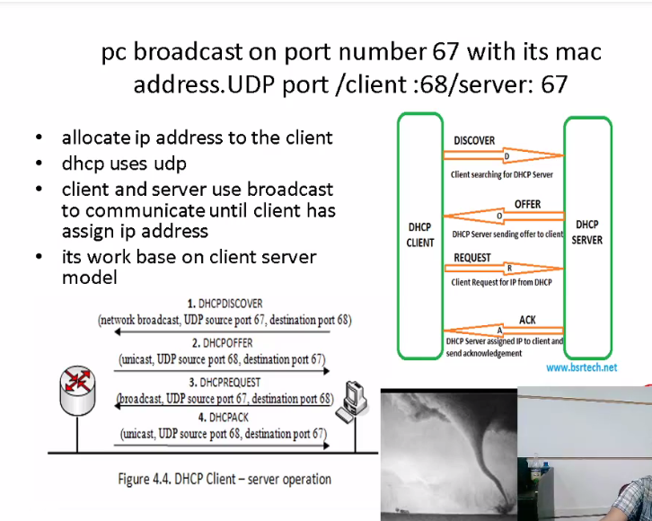

DORA hota h

Client boracdcast krta h discover ki req :D

Apne ip pools k anadar se offer k sth dhcp cline tko bhjdega Server use e kip offer krta h :O

Eg 192.168.1.1 yeh h ap k lye kia ap ise accept krtey h

Pir wo clin t req karega han dedegy

Phir ack ayegaa k apko mil gaye h

PORT:

Client 68

Server 67

Yeh ip assign krtey wqt is max time bhi define krta h k 6 hr tk ap use krskty h us k bd yeh expire hojati h

Toh dobara clinet hoti h clinet ki k barha de ya aagr expire hojati h ip toh kse or client ko assign hojati h

Agar pool sirf 100 ho toh 101 connect nh hopayegi

Ya tph pool barhado ya class B ka ip address use krlo

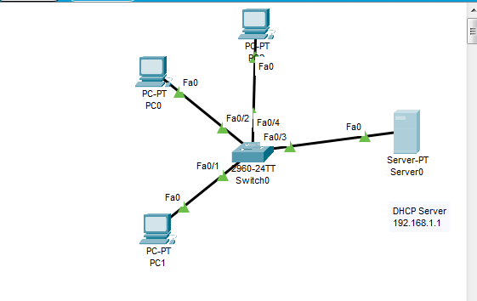

Desktop m ja akr server koi p dene h then

Serverices m ja kr dhcp on krna h

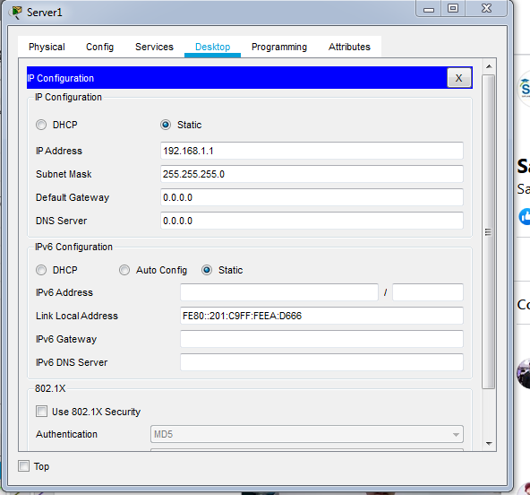

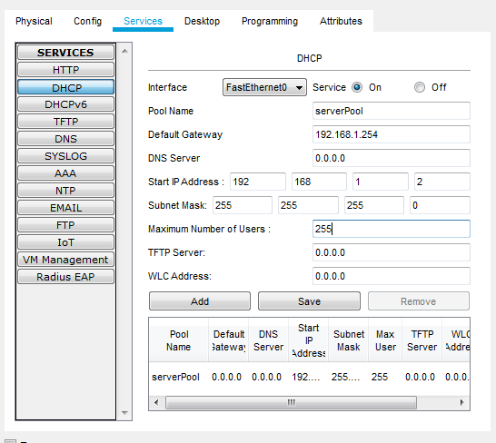

Request ane k bd dhcp broadcast krta h

Client pe dhcp nh h islye wo dicard krrhe h server revcive krrha h

Phir ip ki offer broadcast hogi jinko nh chahye wo sicard krdegy

## Wo offer packet h ius m ip offer hogi jis m actually IP hogi

Request:k han mjhe assign krdein